

Bar Code Labeling Specs

GENERAL INFORMATION

Four types of labels are required depending on how material is packaged for shipment. They are the SINGLE PACK LABEL, SMALL SINGLE PACK LABEL, MASTER LABEL, AND MIXED LOAD LABEL. Every package to the smallest unit shipped must have a label. Each label format is described below.

- All barcodes must be 3 of 9 (39) or 128 code
- All letters on the label should be in UPPERCASE
- All labels are 4 inches X 6 inches (with exception of small pack label, which is 4 inches X 2 inches)
- Do not use dot matrix printers
- Many countries have laws governing how country of origin may be stated, such as “Made In”, “Product Of”, or “Assembled In”. Please use your Country’s laws and regulations to determine the most appropriate statement for country of origin. If your require assistance, please contact Littelfuse by email at CustomsCompliance@Littelfuse.com.

SINGLE PACK LABEL

A Single Pack Label is to be used to identify a single pack containing the same part number, lot number, and PO number. This pack could be a carton or a bag, It is the most commonly used shipping/parts identification label. EVERY INNER BOX AND/OR BAG MUST HAVE A LABEL

Information on a Single Pack Label includes:
  - Littelfuse logo
  - Littelfuse part number [text and barcode]
  - Description of part
  - Quantity (Must be indicated in full numeric values. Abbreviated quantities, such as 6K will not be accepted. The value on the label should read 6000) [text and barcode]
  - Supplier lot number [text and barcode]
    - EVERY LOT NUMBER MUST BE A UNIQUE NUMBER 9 DIGITS AND/OR LETTERS IN LENGTH AND SHOULD NOT BE A DATE ---- A LOT NUMBER SHALL NOT BE USED MORE THAN ONCE IN 365 DAYS. EXAMPLE: 100010101, 100010102, OR 1000101AA, 1000101AB
  - Country of Origin as described above (text and barcode – no data identifier)
  - Purchase order number [text and barcode]
  - Package count
  - Date shipped (format must be YYYYMMDD)
  - Manufacturing Date (format must be YYYYMMDD) [text and barcode]

SIZE OF LABEL = 4 INCHES X 6 INCHES

The specifications in this section apply to the Single Pack Label. This label should be used on ALL cartons, boxes, and/or bags shipped to Littelfuse to the smallest unit. The part number, quantity, supplier lot number, manufacturing date and purchase order numbers are to be displayed in both human readable characters and linear bar code symbols, and must contain a data identifier in the barcode (parentheses are not included in the barcode). The Country of Origin should be in both human readable characters and linear barcode symbols, and does NOT have a data identifier. The description, shipping date, and package count are to be displayed in human readable text only.

BAG - Place one label at the center of face. 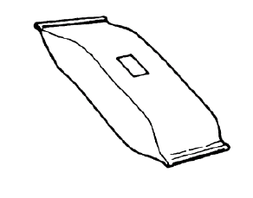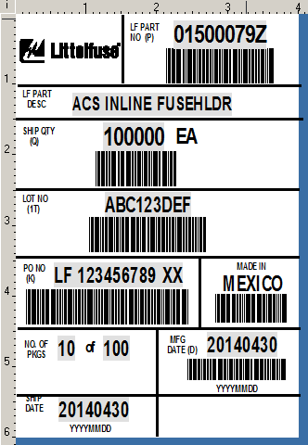

BOX, CARTON, OR HAND WEIGHT CONTAINER – Identical labels must be located on two adjacent sides.
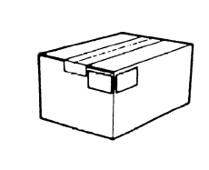

Data Areas and Titles
Shown below is a Single Pack Label.

Data areas must be separated by horizontal and vertical thin lines and are to contain their respective titles, as shown above. Titles should be printed for each field required. All fonts on the label should be bold UPPER CASE.
**Do not use BLANK SPACE ON LABEL

The data area titles for the Single Pack Label are:
- LITTELFUSE LOGO
- PART NUMBER (Data identifier = P)
- PART DESCRIPTION
- QUANTITY (Data identifier = Q)
- SUPPLIER LOT NUMBER (Data identifier = 1T)
  - EVERY LOT NUMBER MUST BE A UNIQUE NUMBER 9 DIGITS AND/OR LETTERS IN LENGTH AND CANNOT BE A DATE ---- A LOT NUMBER CANNOT BE USED MORE THAN ONCE IN 365 DAYS. EXAMPLE: 100010101, 100010102, OR 1000101AA, 1000101AB
- P.O. # (Data identifier = K)
- PKG COUNT
- DATE SHIPPED(format must be YYYYMMDD) – no data identifier
- MANUFACTURING DATE (format must be YYYYMMDD)
Data identifier = D
- COUNTRY OF ORIGIN as described above – no data identifier

SINGLE PACK LABEL EXAMPLE

**ANY RELEVANT REGULATORY SYMBOLS MUST BE ON THE LABEL IN THE BLANK SPACE

SMALL SINGLE PACK LABEL

At times there may be smaller packages sent to LF where the 4 inch X 6 inch label is too large for that particular package. This includes any type of package inside of a carton. If so, below is a smaller single pack label that may be used.

SMALL SINGLE PACK LABEL EXAMPLE

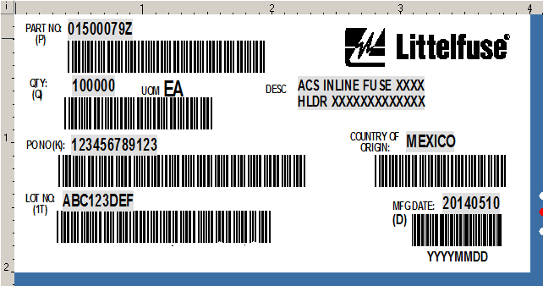

**ANY RELEVANT REGULATORY SYMBOLS MUST BE ON THE LABEL IN THE BLANK SPACE

Information on the smaller Single Pack Label includes:
  - Littelfuse logo
  - Littelfuse part number [text and barcode]
  - Description of part
  - Quantity (Must be indicated in full numeric values. Abbreviated quantities, such as 6K will not be accepted. The value on the label should read 6000) [text and barcode]
  - Supplier lot number [text and barcode]
    - EVERY LOT NUMBER MUST BE A UNIQUE NUMBER 9 DIGITS AND/OR LETTERS IN LENGTH AND SHOULD NOT BE A DATE ---- A LOT NUMBER SHALL NOT BE USED MORE THAN ONCE IN 365 DAYS. EXAMPLE: 100010101, 100010102, OR 1000101AA, 1000101AB
  - Country of Origin as described above (text and barcode – no data identifier)
  - Purchase order number [text and barcode]
  - Manufacturing Date (format must be YYYYMMDD) [text and barcode]

SIZE OF SMALL INNER LABEL = 4 INCHES X 2 INCHES

The specifications in this section apply to the small Single Pack Label. This label should be used on ALL cartons, boxes, and/or bags shipped to Littelfuse that are too small to accommodate the 4 inch X 6 inch label format. The part number, quantity, supplier lot number, manufacturing date and purchase order numbers are to be displayed in both human readable characters and linear bar code symbols, and must contain a data identifier in the barcode (parentheses are not included in the barcode). The Country of Origin should be in both human readable characters and linear barcode symbols, and does NOT have a data identifier. The description does not require a barcode.

Data Areas and Titles

Data areas must contain their respective titles, as shown above. Titles should be printed for each field required. All fonts on the label should be bold UPPER CASE.

The data area titles for the Small Single Pack Label are:

- LITTELFUSE LOGO
- PART NUMBER (Data identifier = P)
- PART DESCRIPTION
- QUANTITY (Data identifier = Q)
- SUPPLIER LOT NUMBER (Data identifier = 1T)
  - EVERY LOT NUMBER MUST BE A UNIQUE NUMBER 9 DIGITS AND/OR LETTERS IN LENGTH AND CANNOT BE A DATE ---- A LOT NUMBER CANNOT BE USED MORE THAN ONCE IN 365 DAYS. EXAMPLE: 100010101, 100010102, OR 1000101AA, 1000101AB
- COUNTRY OF ORIGIN as described above (no data identifier)
- P.O. # (Data identifier = K)
- MANUFACTURING DATE (format must be YYYYMMDD)
(Data identifier = D)

MASTER LABEL

Master Label - Multiple Single Packs of Same Part Number in a carton or on a pallet
A Master Label as shown below is to be used to identify the total contents of a multiple single pack load of the same part number going to one single destination. Please note that material going to multiple destinations must be packaged in a separate load for each destination with a Master Label identifying each.

MASTER PACK LABEL EXAMPLE

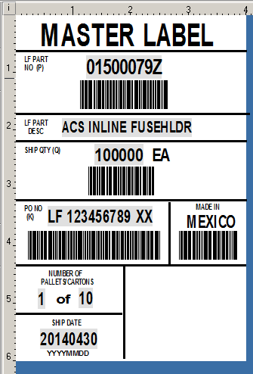

Master Labels are similar in format to Single Pack Labels and are to conform to the same specifications as the Single Pack Label, with the following exceptions:
- The heading MASTER LABEL is to be printed in bold across the top of the label.
- The quantity on the Master Label is to be the total quantity in all sub packs.
- The number of packages will equal the total number of pallets on the load.

***Each carton within the pallet must be identified with a Single Pack Label.
- 2 labels are required
- Identical labels must be located on two adjacent sides.
- All cartons placed on pallet must have labels facing outward (see illustration below)

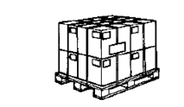
ALL LABELS MUST FACE OUTWARD FOR EASE IN SCANNING

Information on a Master Pack Label includes:

- MASTER LABEL printed across the top of the label format
- Littelfuse part number [text and barcode]
- Description of part
- Total quantity of all cartons (Must be indicated in full numeric values. Abbreviated quantities, such as 6K will not be accepted. The value on the label should read 6000) [text and barcode]
- Country of Origin as described above (text and barcode – no data identifier)
- Purchase order number (if multiple purchase orders are combined on one pallet, there must be a ‘MIXED LOAD” label on the pallet, and individual labels on each carton with the purchase order number) [text and barcode]
- Pallet count
- Date shipped (format must be YYYYMMDD)

SIZE OF LABEL = 4 INCHES X 6 INCHES
The specifications in this section apply to the Master Label. This label should be used on ALL pallets or cartons containing multiple inner cartons of the same part number being shipped to Littelfuse. The part number, quantity, and purchase order numbers are to be displayed in both human readable characters and linear bar code symbols, and must contain a data identifier in the barcode (parentheses are not included in the barcode). The Country of Origin should be in both human readable characters and linear barcode symbols, and does NOT have a data identifier. The description, pallet count, and date shipped are to be displayed in human readable text only.

EACH CARTON ON THE PALLET MUST BE LABELED AS DESIGNATED IN THE SINGLE PACK LABEL SECTION ABOVE WITH ALL LABELS FACING OUTWARD

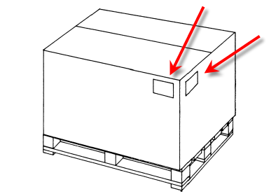
IDENTICAL LABELS MUST BE LOCATED ON TWO ADJACENT SIDES OF THE PALLET

IF ONE CARTON IS BEING SHIPPED WITH MUTIPLE CARTONS INSIDE, PLACE TWO ADJACENT MASTER LABELS ON OUTSIDE OF CARTON.

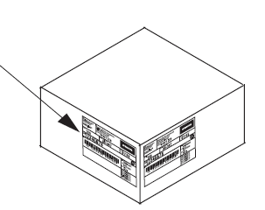

ADDITIONAL PICTURES OF MASTER LABEL PLACEMENT ON A PALLET IS BELOW

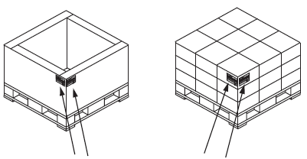

Data Areas and Titles
Shown below is a Master Pack Label.

Data areas must be separated by horizontal and vertical thin lines and are to contain their respective titles, as shown above. Titles should be printed for each field required. All fonts on the label should be bold UPPER CASE.

The data area titles for the Master Label are:

- MASTER LABEL printed across top of label
- PART NUMBER (Data identifier = P)
- PART DESCRIPTION
- QUANTITY (Data identifier = Q)
- P.O. NUMBER (Data identifier = K)
- COUNTRY OF ORIGIN as described above (text and barcode – no data identifier)
- PALLET COUNT
- SHIP DATE (format must be YYYYMMDD)

MIXED LOAD LABEL

A Mixed Load Label is to be used for containers, pallets, skids, etc., holding more than one single pack of different part numbers and/or different lot numbers going to one single destination.

A Mixed Load Label as shown below is to be used to identify a load of multiple single packs of different part numbers and/or lot numbers going to one single destination.

Please note: material going to multiple destinations must be packaged in a separate load for each destination with a Mixed Load Label identifying each.

Mixed Load Labels must conform to the following specifications:

- Littelfuse Logo
- MIXED LOAD printed across the label
- Pallet number and total number of pallets or carton number and total number of cartons
- Date shipped (format must be YYYYMMDD)

***Each carton within the pallet must be identified with a Single Pack Label.
- 2 MIXED LOAD labels are required
- Identical labels must be located on two adjacent sides.

All data on the label is to be displayed in human readable text only.

SIZE OF LABEL = 4 INCHES X 6 INCHES
The specifications in this section apply to the MIXED LOAD Label. This label should be used on ALL pallets or cartons containing multiple inner cartons of different part numbers and/or multiple lot numbers being shipped to Littelfuse. The information on the label is to be displayed in human readable text only.

LABEL LOCATIONS FOR A CARTON WITH MIXED PARTS

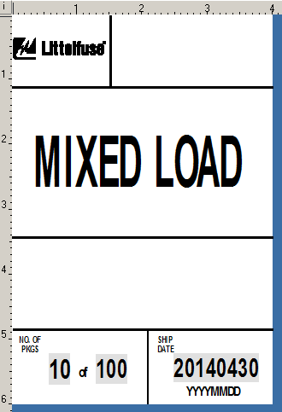

LABEL LOCATION FOR A PALLET WITH MIXED PARTS
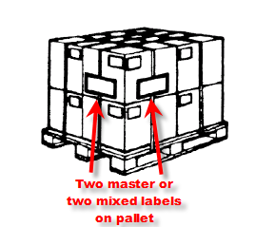

*** Identical labels must be located on two adjacent sides OF ALL CARTONS AND PALLETS.

Data Areas and Titles
Shown below is a Mixed Load Label.

Data areas must be separated by horizontal and vertical thin lines and are to contain their respective titles, as shown below. Titles should be printed for each field required. All fonts on the label should be bold UPPER CASE.
The data area titles for the Mixed Load Label are:

- LITTELFUSE LOGO
- MIXED LOAD ACROSS TOP OF LABEL
- CARTON OR PALLET NUMBER AND CARTON OR PALLET COUNT
- SHIP DATE (Date format must be YYYYMMDD)

EXAMPLE OF MIXED LOAD LABEL

