- REFERENCES
  - P571-7.4.0-014 Supplier Rejections and Corrective Action Resolution
- DEFINITIONS
  - None.
- CLARIFICATION OF PROCESS STEPS
  - If at any time you have problems using the caWeb system, please contact the appropriate Administrator.
Supplier Development Engineer  North America/European Suppliers  +1 773 628 0854 | Supplier Development Engineer  Asia Suppliers  +86 512 6761 3189
  - Enter the caWeb system by logging into the system with assigned user name and password (Figure 1). The web page may be accessed through http://www.littelfuse.com/ (click “Login” in the upper left corner of the screen) or directly to http://caweb4.hginet.com/lfsupplybase/. Your caWeb Administrator will provide you with your login and password information prior to first use.
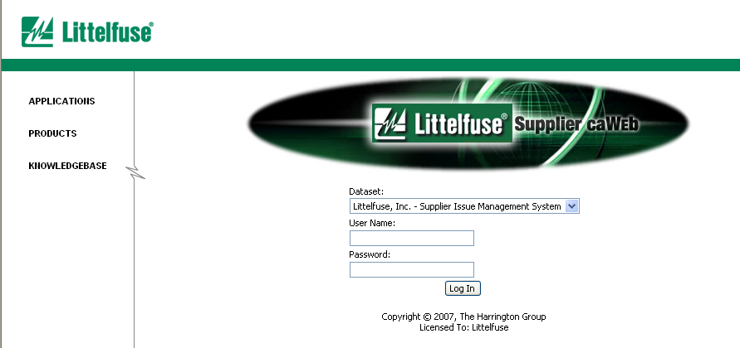
Figure 1 - System Login Screen Shot

  - To display the list of problem reports, click on the Problems link to expand the menu choices, and then click on Problem List (see Figure 2). Select a query at the top of the problem list to display problem reports as needed. To open the problem report, click on the corresponding underlined report number shown to the right.
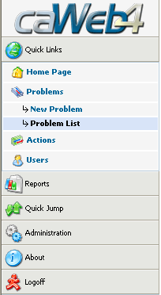
Figure 2 - Link to Problem List Screen Shot

  - The Problem List will show basic information related to any pending rejections: Problem Number, Problem Description, Part Number, Part Name, and Date of Rejection. To select a particular problem, click on the highlighted line with your mouse. See Figure 3 Below.
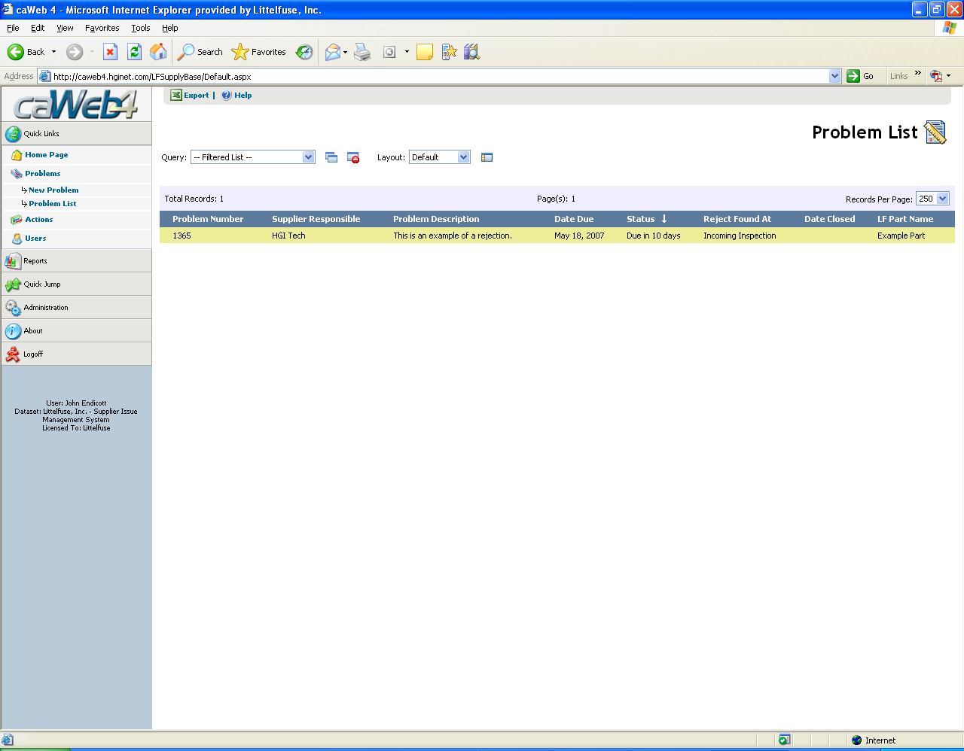
Figure 3 - Viewing a Problem List Screen

  - Any time a problem report is initiated, the Supplier’s Quality Representative will be auto-notified via email.
For the justified issue, Littelfuse requires the supplier to input their 3D response (team assigned and
containment actions) within 24 hours. At a minimum a 5D (root cause analysis, corrective action items)
needs to be completed within 10 days.

    - When Supplier’s Quality Representative receives the caweb notification, supplier needs to set up QIT(Quality Improvement Team) for the notified issue and input the team member on the caweb column immediately as ‘1D’
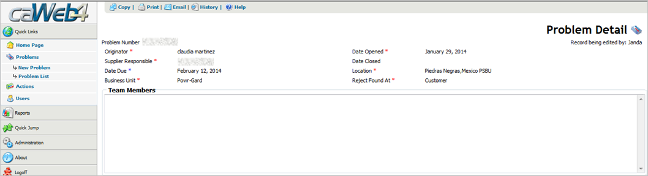
Figure 4-1D – Team Members Column Screen Shot
    - When supplier’s QIT is set up, supplier should confirm with Littelfuse about the problem description like: P/N, Lot number, defective quantity and related impact and then update the problem description column as ‘2D’
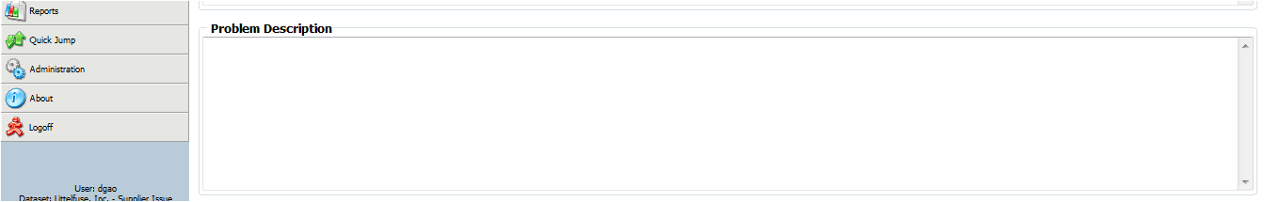
Figure 4-2D –Problem Description Column Screen Shot
    - When the problem description is confirmed, supplier QIT should provide the interim containment actions based on the quality issue description and update the containment actions in the caweb column as ‘3D’. The containment actions should include ‘Quality alert in place’, confirm the ‘Material in process’ , the ‘Material in warehouse’, the ‘Material in transit’ and check with SDE/Buyer about the ‘Quantity in Littelfuse stock’, also need to provide the ‘Certification mark after improvement’ and inform customer about the ‘Conforming material expected date’.
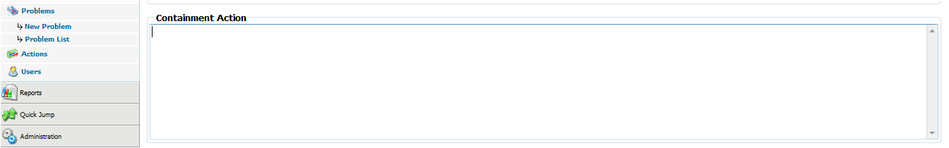
Figure 4-3D –Containment Actions Column Screen Shot
    - When supplier finishes the 3D within 24 hours, QIT should implement the root cause analysis by steps. Supplier need to analyze all the potential "Root Causes" of the issue reported by the customer and note the root cause. Root cause analysis should be defined by one or more of next tools: 5 why, Brainstorm or Fish Bone Diagram. Based on the multidisciplinary team analysis, supplier need to describe the actions used to verify the root causes and sometimes need to explain how the failure mode was reproduced. And then analyze all the potential "Root Causes" of the issue reported by the customer. Underline the escape point and circle the root cause. After those root cause analysis steps, supplier needs to state the root cause in caweb column as ‘4D’;
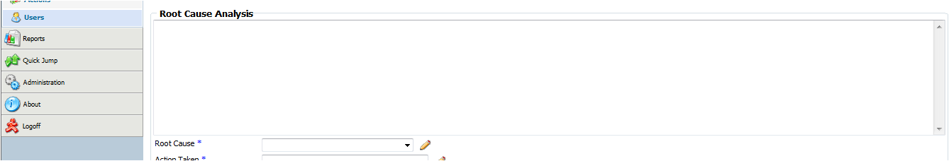
Figure 4-4D –Root Cause Analysis Column Screen Shot
    - Supplier needs to take the actions to correct/eliminate the problem which clearly linked to the root cause identified in 4D, for both failure of occurrence and failure of detection, then summarize the detailed actions on the caweb system column as ‘5D’ (Corrective Actions column)
    - After supplier finish the 5D, they need to take the actions to validate the permanent corrective actions by supporting data linked to all individual corrective action (in 5D) for failure occurrence and detection and then summarize the data in caweb system as ‘6D’;(Verification Actions Column)
    - Supplier needs to take the actions to eliminate the potential problem across product family or other processes that may have similar risk, the actions should focus on the system improvement including management system manual, manufacturing/inspection work instruction, process flow chart and control plan, PFMEA, engineering change etc. then summarize the key systematic improvement items in caweb column as ‘7D’(Preventive actions column)
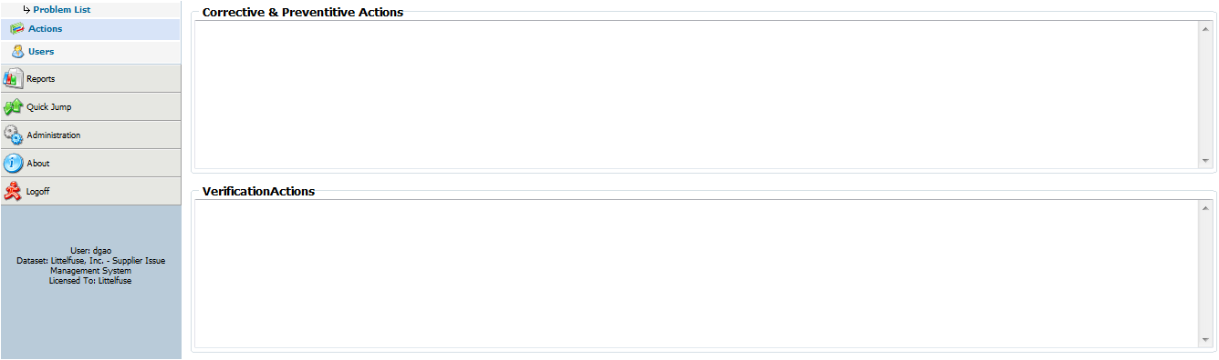
Figure 4-5D-6D-7D –CA/PA/Verification Actions Column Screen Shot
    - After finishing the 7D, supplier QIT should review the 7D report with internal team and get the approval by each involved department managers and then share the lesson learned to other similar product team and implement the corrective actions and preventive actions across the entire product categories when applicable. Summarize those lesson learned information as the ‘8D’ for the issue closure.
    - When supplier finishes the 8D report, they should upload the 8D report by using Littelfuse form with related evidence of improvement onto the attachments column before the issue due date and then send an email to notify Littelfuse about the 8D report confirmation and issue closure.
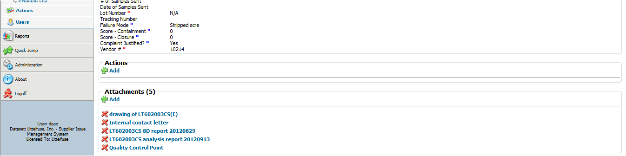
Figure 4-8D –Attachments Column Screen Shot
  - If an extension is required, you must contact your Littelfuse Supplier Development Engineer or your Littelfuse Buyer as early as possible. If the request comes after the normal due date, it will be reviewed on a case-by-case basis to allow an extension.
  - Action Items
    - Action items are used occasionally by Littelfuse to identify medium to long-term projects that will need a follow-up at a later date. They can be created independent of a corrective action or in conjunction with it. Notifications for Action Items are very similar to notifications for Corrective Action Requests. Action Items can be accessed from the Menu by clicking on Actions, then clicking on Action List (see Figure 5 below).
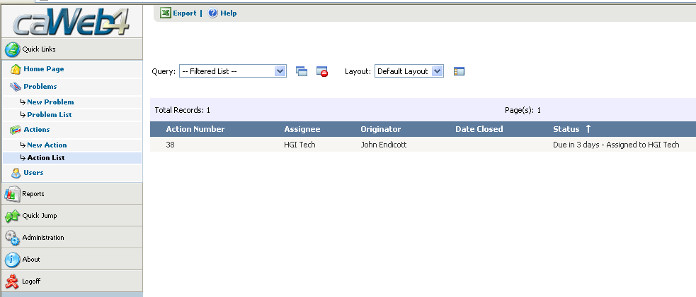
Figure 5- Screenshot of the Action List
    - Otherwise, an action item can be accessed from the corrective action in the Actions section (see Figure 6 below). Complete any notes or results as they become available. Please note that Action Items have due dates that are independent of the corrective action.
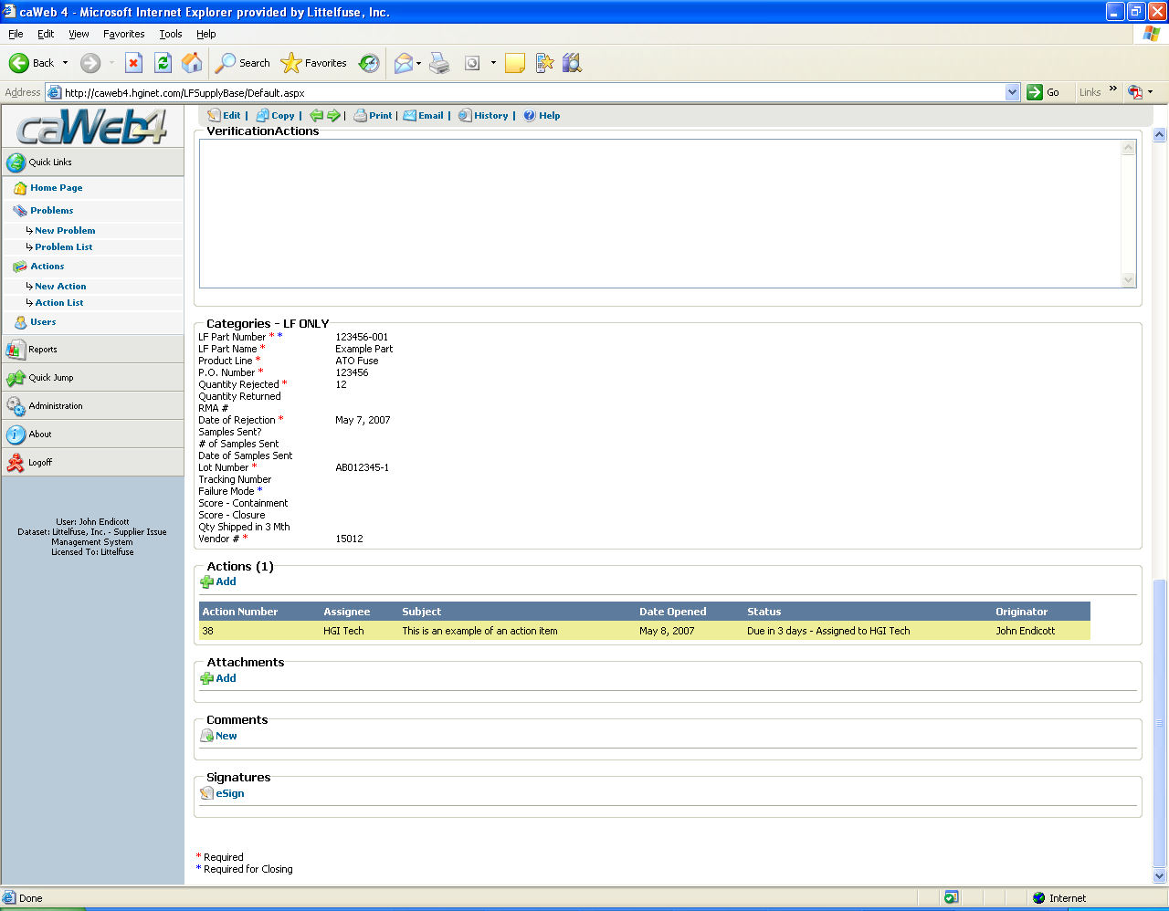
Figure 6 - Accessing an Action Item from a Corrective Action

  - Attachments
    - Photos and/or attachments (if available or applicable) will be included in the rejection notice to help communicate the problem description. Supporting evidence via photos and/or attachments (revised work instructions, visual aids, etc) are encouraged to help understand implemented actions and communicate effectiveness.
    - Click ‘Add’ in the Attachments section, then enter a file description that adequately describes the type of file you are attaching. If you know the path, enter it, or click browse to find the file you want to attach. You can also choose to enter a URL to a website. (see Figure 7 below)
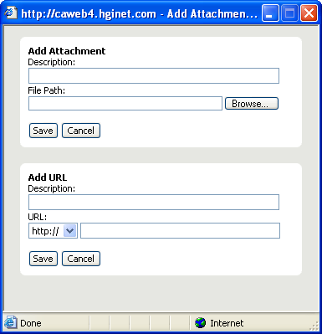
Figure 7 - File Attachment Screen Shot
    - Click ‘Save’. Repeat 3.7.1 – 3.7.2 for any additional attachments.
  - Once all fields and attachments are completed, an email must be sent via caWeb to the ‘Originator’ (see Figure 8) whenever a response has been updated, especially when the issue is awaiting approval for closure.
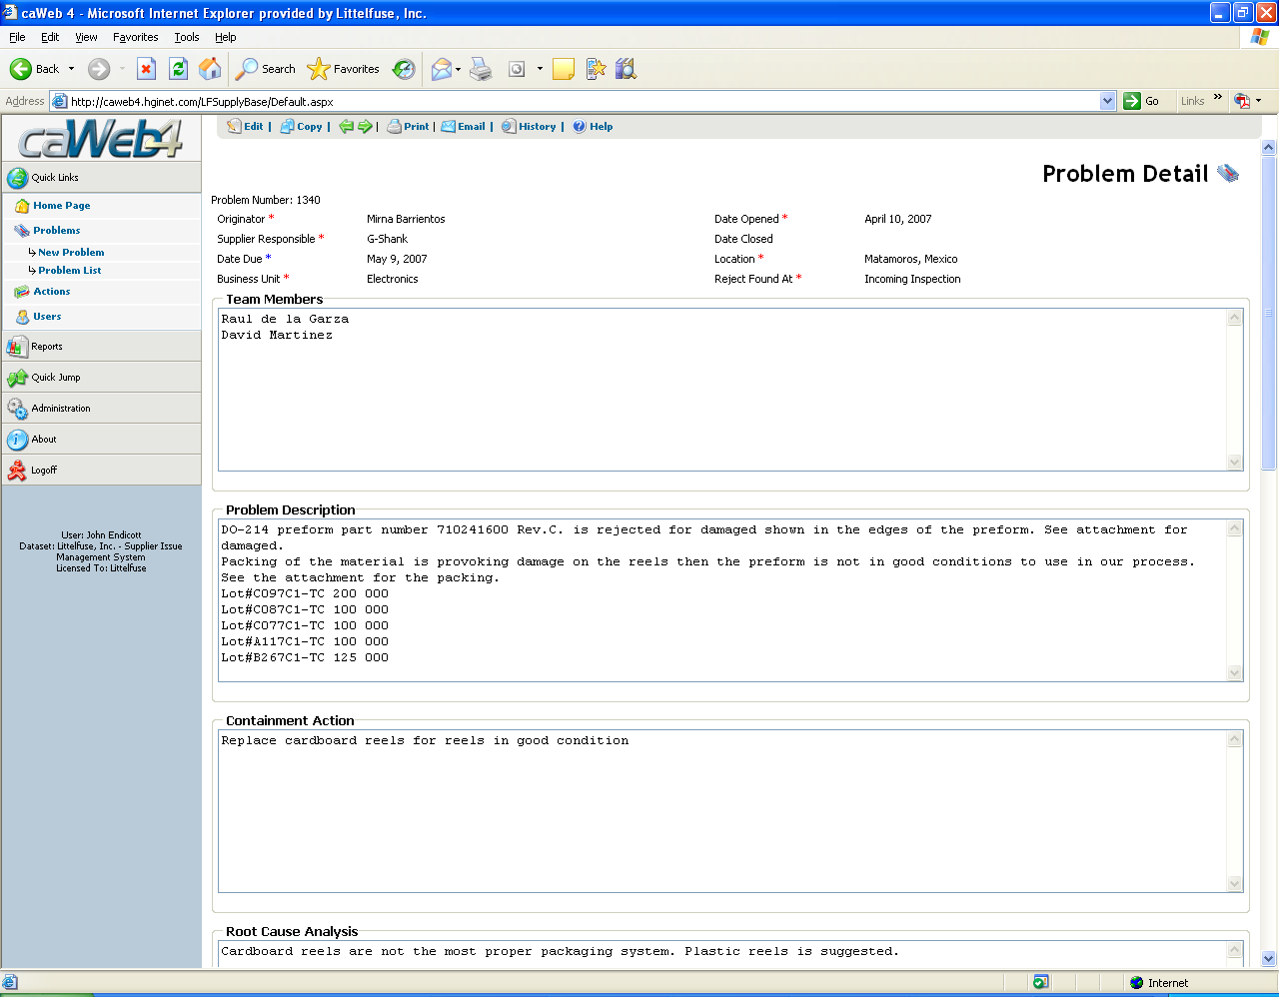
Figure 8 - Email Button Screen Shot
  - Suppliers and Originator will be reminded daily of overdue issues via e-mail. Monthly scoring of supplier performance will be affected by timeliness to due date. Any exceptions or changes to assigned problem reports/issues must be approved by the problem originator.
  - Score for containment and closure
    - Score for containment and score for closure need to be filled by originator before the originator close the issue. This score is used to calculate the supplier responsiveness and will affect the supplier monthly performance in scorecard. There is a drop down list in these two fields (see Figure 9). The drop down list include two values “0” and “1”. “0” means the supplier doesn’t reply on time, and “1” means on time.
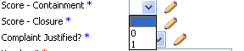
Figure 9 – Score Drop down List
    - Score for Containment: Supplier should take containment action within 24 hours after the originator issue a caWeb complaint. All kinds of containment responses from supplier consider effective, include email, phone call confirm, or write down the containment action in caWeb and etc.
    - Score for Closure: Supplier need to complete the 5D report (root cause analysis and corrective actions items) with 10 working days or within the due date the originator defined.
- RESPONSIBILITIES
  - It is the responsibility of the Director of Global Purchasing Department or his/her designee to see that the terms of this procedure are carried out.
- RECORDS
  - Electronic Records are maintained in accordance with the Quality Administrative Procedure (P596-4.2.4-001).
- CHANGES
  - Initial Revision.
  - Add 3.11.
  - Add 3.2.1 to 3.2.9 for the caweb 8D requirement
- ATTACHMENTS
  - Supplier caWeb Process Map – This process describes the supplier’s responsibility and the process to follow when issued a corrective action request by Littelfuse.
Figure 10 - Supplier caWeb Process

